hamza hazem

HTU

Big Data

Final Report

Table of Contents

Introduction 3

Overview of Big Data 3

In today's world, the rise of "Big Data" has been driven by the massive amount of structured and unstructured data generated at incredible speed from all kinds of sources. From transactional records to social media interactions, this data is huge and complex, making it difficult to manage with traditional tools. 3

Importance of Big Data 3

Big Data has transformed how organizations function and make decisions. By analyzing large datasets, businesses can gain insights that drive strategic decisions, streamline operations, and improve customer experience. Companies in industries like finance, healthcare, and retail are leveraging Big Data to stay ahead of the competition, forecast trends, and tailor their products or services to individual needs. 3

Project Objective 3

This project aims to explore, manipulate, and visualize Big Data using Apache Spark, a powerful open-source distributed computing tool. The main goal is to showcase Spark's ability to handle large datasets by collecting, processing, and analyzing data from an online travel platform. The site offers services like air travel, hotels, and local tours, producing significant data from customer activities and transactions. 3

BIG DATA Tools 3

Advantages of PySpark as a Big Data Tool 3

Data Preparation, Cleansing, and Manipulation 4

DF1: Statistical and Visualization Techniques Used for Data Analysis 5

DF2: Statistical and Visualization Techniques Used 7

Merged_df: Statistical and Visualization Techniques Used 9

Key Interpretation and Findings, Visualization Approaches, Data Preprocessing Justification, and Model Effectiveness Evaluation 10

Hadoop vs. Spark 13

Advantages and Challenges of Data Preparation and Sourcing in the Given Scenario 16

Stages of the Big Data Lifecycle Using Complex Data Sets and Its Impact on Decision-Making 19

Discussion of Hive and Apache Spark Architecture and Components 21

# Introduction

## Overview of Big Data

## In today's world, the rise of "Big Data" has been driven by the massive amount of structured and unstructured data generated at incredible speed from all kinds of sources. From transactional records to social media interactions, this data is huge and complex, making it difficult to manage with traditional tools.

## Importance of Big Data

## Big Data has transformed how organizations function and make decisions. By analyzing large datasets, businesses can gain insights that drive strategic decisions, streamline operations, and improve customer experience. Companies in industries like finance, healthcare, and retail are leveraging Big Data to stay ahead of the competition, forecast trends, and tailor their products or services to individual needs.

## Project Objective

## This project aims to explore, manipulate, and visualize Big Data using Apache Spark, a powerful open-source distributed computing tool. The main goal is to showcase Spark's ability to handle large datasets by collecting, processing, and analyzing data from an online travel platform. The site offers services like air travel, hotels, and local tours, producing significant data from customer activities and transactions.

# BIG DATA Tools

## Advantages of PySpark as a Big Data Tool

PySpark, is an interface for Apache Spark, offering several key advantages for big data processing and machine learning:

1. **Scalability**: PySpark has the ability to process massive datasets across distributed clusters, making it essential for handling large volumes of data, like the online travel site data in our project, efficiently managing millions of customer interactions.
2. **Fault Tolerance**: PySpark make sure for data replication and recovery automatically. If a node in the cluster fails, Spark's resilient distributed datasets (RDDs) keep the data processing going without data loss.
3. **In-Memory Computing**: Through processing data in memory, PySpark is much faster than traditional disk-based systems. Which speeds up tasks like data analysis and machine learning model training.
4. **Seamless Integration**: PySpark integrates smoothly with other big data tools like Hadoop and HDFS and supports multiple languages, including Python, which is very good for data scientists that already use Python libraries like Pandas, scikit-learn, and matplotlib.
5. **Efficient Machine Learning**: With PySpark's MLlib library, you get scalable machine learning tools which support algorithms like decision trees, linear regression, and Random Forest, making it ideal for training models on large datasets.
6. **User-Friendly API for Data Manipulation**: PySpark’s easy-to-use API makes data cleaning and transformation simplified, allowing us to prepare raw data for analytics and machine learning, which is useful when working with unstructured data from APIs, as in our case.

## Data Preparation, Cleansing, and Manipulation

• **Data Collection**:

* Data was gathered via an API request to the Airbnb API using the requests library. The JSON response was stored in a file for further analysis, making it easier to manage and process.

• **Loading Data into PySpark**:

* Once the data was collected, it was loaded into a PySpark DataFrame using spark.read.json(). This allowed the data to be processed in parallel across the cluster, taking full advantage of PySpark’s distributed architecture for efficiency.

• **Exploratory Data Analysis (EDA)**:

* **Schema Inspection**: The structure of the data was examined using .printSchema(), helping to identify data types and potential transformations needed.
* **Viewing Data**: You used .show(5) to get a quick look at the first few rows of the datasets, providing an overview of its contents.
* **Summary Statistics**: With .describe().show(), we calculated summary statistics to understand the key metrics of the numerical data, such as mean and standard deviation.
* **Missing Values**: A check for missing values was performed using isnull() and counted with count(), addressing the common real-world issue of incomplete data.

• **Data Cleansing**:

* **Handling Missing Values**: Rows with null values were removed using .dropna(). While this is a simple approach, it can lead to data loss, so it’s essential to balance this step with the need to retain valuable information.
* **Removing Duplicates**: Duplicates were identified using groupBy().count() and filtered out. Removing duplicates ensures cleaner data and prevents skewed results.

• **Data Transformation and Manipulation**:

* **Feature Selection**: Random Forest was used to identify the most important features in the dataset, narrowing down the analysis to those that matter most for predictions.
* **Label Encoding**: Categorical data was converted to numerical form using LabelEncoder, a necessary step for machine learning models that don’t handle string inputs.
* **Splitting Data**: The dataset was split into training and testing sets using randomSplit(). This ensures that the model’s performance is validated on unseen data, reducing the risk of overfitting.

• **Advanced Feature Engineering**:

* **Pipeline for Data Transformation**: We implemented a PySpark pipeline using StringIndexer, OneHotEncoder, and VectorAssembler to handle transformations efficiently. This pipeline ensured consistent application of the transformations across both training and testing datasets.
* **Scaling and Dimensionality Reduction**: Feature scaling was done with StandardScaler and dimensionality reduction was applied using PCA. Scaling ensures uniform feature ranges, while PCA focuses on the most critical components, reducing the computational complexity.

• **Merging Datasets**:

* The two datasets, df and df2, were merged on the host_name column using an inner join. This combined both dataset’s relevant information, improving the analysis with additional context like neighborhood and host experience, resulting in more insightful conclusions.

## DF1: Statistical and Visualization Techniques Used for Data Analysis

**Statistical Techniques:**

* **Descriptive Statistics**: Key metrics like mean, median, standard deviation, and count were calculated to understand the central tendency and distribution of variables such as Booking_total, Review_rate_number, and Host_Revenue.
* **Group-by and Aggregations**: We grouped data by categorical variables, such as State, to compute the average Review_rate_number and identify high-performing regions. Similarly, grouping by Property_type allowed us to compare revenue across different property types.
* **Handling Missing Values**: Missing data was addressed by filtering or dropping null values to maintain data integrity, ensuring accurate and reliable analysis.

**Visualization Techniques:**

* **Histogram**: Used to visualize the distribution of Booking_total, the histogram revealed patterns like skewness and normality, helping us understand the frequency of various booking amounts.

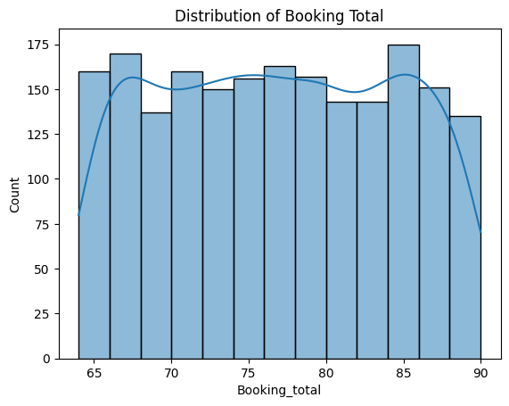

* **Boxplot**: Two boxplots were created—one comparing Host_Revenue across Property_type and another comparing Host_Experience with Review_rate_number. These boxplots highlighted the spread, outliers, and variance in the data.

* **Bar Plot**: A bar plot was used to visualize the average platform revenue across different construction years. This approach shows the trend of platform revenue over time by aggregating the data for each year, making it easier to observe patterns in how properties from different construction years contribute to platform revenue. The plot reveals that properties constructed between 2013 and 2016 tend to generate higher revenue on average compared to other years. This information can be useful for targeting properties from these years in marketing efforts or investment strategies.

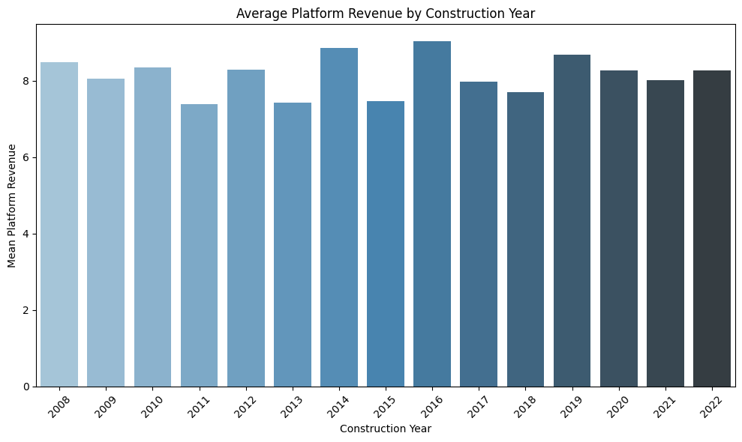

* **Barplot**: To compare the average Review_rate_number across states, a barplot was generated to easily spot which states had the highest customer reviews.

**Critical Evaluation of Tools and Suitability for Decision-Making:**

1. **Histogram for Booking Total**:
   * **Suitability**: The histogram is well-suited for showing the frequency distribution of booking totals, while the KDE smooths out the data, making patterns more recognizable.
   * **Support for Decision-Making**: This helps the platform identify popular booking ranges, allowing it to adjust promotions and resources accordingly.
2. **Boxplot for Host Revenue vs. Property Type**:
   * **Suitability**: A boxplot is ideal for comparing the variance in revenue across property types, effectively visualizing outliers and medians.
   * **Support for Decision-Making**: Helps optimize pricing strategies by focusing on property types that generate the highest median revenue.
3. **Boxplot for Host Experience vs. Review Rate Number**:
   * **Suitability**: The boxplot highlights the distribution of review scores based on host experience, revealing trends and outliers.
   * **Support for Decision-Making**: Insights from this data can guide whether to focus more on experienced hosts or offer support to newer hosts to improve their review scores.
4. **Bar Plot for Average Platform Revenue by Construction Year:**

* **Suitability:** This bar plot is well-suited for identifying trends in platform revenue across different construction years. By aggregating and comparing average revenues for properties from each year, it provides a clearer overview of how property age influences revenue.
* **Support for Decision-Making:** The insights from this plot can inform marketing strategies, particularly for properties constructed in years that show higher average revenue. For instance, properties from 2013 to 2016, which have higher average revenue, may be targeted for special promotions or campaigns, while properties from other years can be further analyzed to identify improvement opportunities.

1. **Barplot for Top 5 States by Average Review Rate Number**:
   * **Suitability**: The barplot provides a quick comparison of review rates across states, making it easy to identify which regions perform best.
   * **Support for Decision-Making**: This allows the platform to focus promotions on states with the highest engagement, helping increase overall customer interaction.

## DF2: Statistical and Visualization Techniques Used

1. **Distribution of Prices (0 - 5000):**

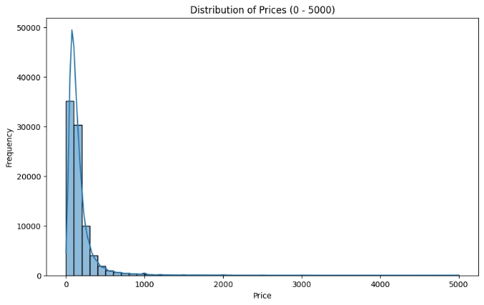

* + **Statistical Technique**: A histogram with KDE was used to show the price distribution. Most prices were concentrated below 1000, with a long tail extending up to 5000.
  + **Decision-Making**: This insight helps fine-tune pricing strategies and target customer segments based on their price sensitivity.

1. **Room Type vs. Price:**

* + **Statistical Technique:** A barplot was used to compare the average price across the top 5 room types. Hotel rooms were the most expensive, followed by entire homes/apartments.
  + **Decision-Making:** This informs pricing recommendations, ensuring prices align with room types and customer preferences.

1. **Top 5 Neighborhood Groups by Number of Listings:**

* + **Statistical Technique:** A count plot was employed to show the number of listings in the top 5 neighborhood groups.
  + **Decision-Making:** This guides marketing efforts toward high-demand areas like Manhattan and Brooklyn, ensuring resources are focused on popular regions.

1. **Reviews per Month vs. Availability (365 days):**

* + **Statistical Technique**: A scatterplot revealed the relationship between reviews_per_month and availability_365. Listings with higher availability typically had fewer reviews.
  + **Decision-Making:** This helps adjust recommendations for high-availability listings, improving their visibility or adjusting promotional efforts.

1. **Number of Reviews vs. Minimum Nights:**

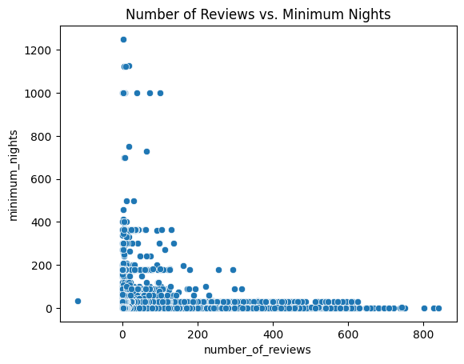

* + **Statistical Technique:** A histogram was used to show the relationship between number_of_reviews and minimum_nights.
  + **Decision-Making**: The analysis suggests that lowering minimum-night requirements could lead to higher engagement and more reviews.

**Critical Evaluation of Tools and Suitability:**

1. **Histograms:**
   * **Suitability**: Ideal for visualizing the distribution of prices and understanding data spread.
   * **Limitations**: Histograms are less effective for exploring relationships between multiple variables.
2. **Barplots:**
   * **Suitability**: Highly effective for comparing categories like room types or neighborhoods.
   * **Limitations**: Barplots focus on aggregated data and don’t show how variables relate to one another.
3. **Count Plots:**
   * **Suitability**: Best for categorical data analysis, such as the number of listings in different neighborhoods.
   * **Limitations**: These plots lack insights into key factors like review quality or revenue potential in the analyzed areas.
4. **Scatterplots:**
   * **Suitability**: Excellent for identifying trends and correlations between variables, such as availability and reviews.
   * **Limitations**: Scatterplots can become cluttered and difficult to interpret when there are too many data points, potentially obscuring patterns.

## Merged_df: Statistical and Visualization Techniques Used

1. **Platform Revenue by City (Barplot)**:

* + **Statistical Technique**: A barplot was used to display the total platform_revenue generated by different cities.
  + **Decision-Making**: This insight directs marketing efforts toward high-revenue cities like New York and Los Angeles, allowing for better resource allocation.

1. **Reviews per Month vs. Minimum Nights (Scatterplot)**:

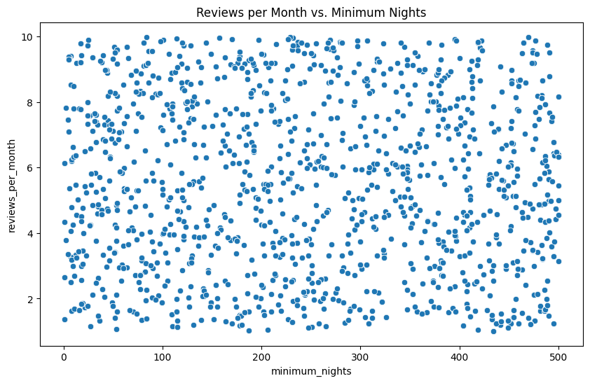

* + **Statistical Technique**: A scatterplot was employed to explore the relationship between reviews_per_month and minimum_nights.
  + **Decision-Making**: The analysis suggests focusing on other factors beyond minimum night requirements to improve the number of reviews.

1. **Review Rate by Host Listings (Boxplot)**:

* + **Statistical Technique**: A boxplot showed the distribution of review_rate_number based on the number of listings managed by hosts.
  + **Decision-Making**: This encourages prioritizing hosts who manage more listings, as they generally receive higher review rates, which can improve overall customer satisfaction.

1. **Room Type Distribution (Pie Chart)**:

* + **Statistical Technique**: A pie chart was used to illustrate the proportions of different room types available on the platform.
  + **Decision-Making**: These insights help guide decisions about whether to diversify offerings or emphasize popular room types like entire homes and private rooms.

**Critical Evaluation of Tools and Suitability:**

1. **Barplots**:
   * **Suitability**: Excellent for comparing revenue contributions across cities, giving a clear picture of which locations generate the most revenue.
   * **Limitations**: Barplots don’t show time-based trends, so additional visualizations may be needed to track changes over time.
2. **Scatterplots**:
   * **Suitability**: Scatterplots are great for identifying correlations between variables like reviews and minimum nights, revealing potential trends.
   * **Limitations**: With large datasets, scatterplots can become cluttered, making it harder to interpret specific patterns.
3. **Boxplots**:
   * **Suitability**: Ideal for displaying variability and outliers, especially in host listing data where different hosts manage varying numbers of properties.
   * **Limitations**: Boxplots can be complex for non-technical stakeholders to fully understand without explanation.
4. **Pie Charts**:
   * **Suitability**: Useful for visualizing proportions, especially when comparing room types.
   * **Limitations**: Pie charts become less effective with many categories, where bar charts might offer clearer and more detailed comparisons.

# Key Interpretation and Findings, Visualization Approaches, Data Preprocessing Justification, and Model Effectiveness Evaluation

## 1. Key Interpretation and Findings

While evaluating the three classification models—Logistic Regression, Random Forest, and Decision Tree—using metrics such as accuracy, precision, recall, and F1-score, the following insights were derived:

* **Logistic Regression**: Achieved strong performance with an accuracy of 0.81, precision of 0.82, and F1-score of 0.81. These metrics suggest that Logistic Regression generalizes well to the dataset, offering a balanced trade-off between precision and recall. While not suffering from overfitting as in the previous case, it provides reliable results with reasonable accuracy, making it a suitable model for this dataset.
* **Random Forest Classifier**: Showed a lower accuracy of 0.40 but relatively high precision at 0.74, indicating that while it captures some patterns, it struggles to generalize effectively, as seen in the lower recall and F1-score of 0.42. This imbalance between precision and recall suggests that the model is more conservative in making positive predictions but misses a significant number of true positives.
* **Decision Tree Classifier**: With an accuracy of 0.50 and an F1-score of 0.47, the Decision Tree model performed moderately, slightly outperforming the Random Forest in terms of accuracy but not precision or recall. Its lower precision and F1-score indicate challenges in balancing true positives and negatives, suggesting that this model struggles with generalization due to possible overfitting.

In conclusion, **Logistic Regression** emerges as the most reliable model in this scenario, demonstrating balanced performance across all metrics, while **Random Forest** and **Decision Tree** show some limitations in handling the complexity of the dataset.

## 2. Plotting and Visualization Approaches

Various visualizations were used to interpret and compare the performance of these models:

1. **Bar Plot of Model Performance Metrics**:

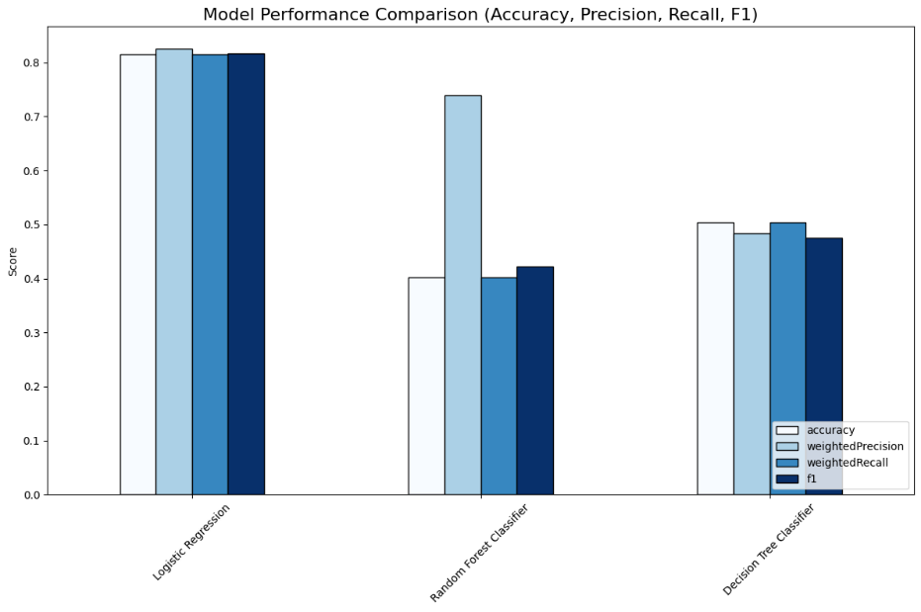

* + **Purpose**: This plot provided a side-by-side comparison of accuracy, precision, recall, and F1-scores across all three models. It clearly highlighted the reliability of Logistic Regression and the relatively weaker performance of Random Forest and Decision Tree.
  + **Justification**: A bar plot is well-suited for this type of comparison, offering a clear visual distinction between different models and metrics. Other options, like line plots, would be less effective for comparing categorical metrics.

1. **SHAP Feature Importance**:
   * **Bar Plot**: This plot highlighted the average impact of each feature on the model’s output, identifying platform_revenue and reviews_per_month as the most influential variables.

* + **Summary Plot**: Provided a detailed look at how high and low values of key features impacted model predictions.

* + **Justification**: SHAP visualizations were chosen to explain the "black-box" nature of models like Random Forest and Decision Tree, making it easier to understand which features had the most impact on predictions.

## 3. Data Preprocessing and Manipulation

Several preprocessing steps were critical to ensuring that the models could train effectively:

1. **Label Encoding**:
   * **Reasoning**: Categorical variables like room_type and neighborhood were converted into numerical values using label encoding. This was necessary since machine learning models require numerical inputs.
2. **Handling Missing Data**:
   * **Reasoning**: Missing values were filled or removed to prevent errors during model training. This ensured data consistency and stability, reducing the likelihood of biased results.
3. **Feature Assembly**:
   * **Reasoning**: The top 7 features, as identified by SHAP, were combined into a feature vector to streamline the modeling process. This reduced the dimensionality of the data, helping to avoid overfitting.

## 4. Evaluation of Model Effectiveness

The effectiveness of the models was evaluated using accuracy, precision, recall, and F1-score, revealing their respective strengths and weaknesses:

1. **Logistic Regression**:
   * **Effectiveness**: With an accuracy of 0.81 and balanced precision, recall, and F1-scores, Logistic Regression demonstrated reliable performance, making it the strongest model in this evaluation. The absence of overfitting, as seen in previous trials, indicates the model generalizes well to the dataset.
   * **Evaluation**: The relatively high and balanced metrics make Logistic Regression suitable for real-world applications, as it efficiently handles the dataset without being overly reliant on the training data.
2. **Random Forest Classifier**:
   * **Effectiveness**: Random Forest delivered moderate results, with an accuracy of 0.40 and a high precision of 0.74. However, the low recall (0.40) and F1-score (0.42) indicate that while the model is effective in identifying certain patterns, it struggles to capture a balanced number of true positives, suggesting an imbalance in prediction.
   * **Evaluation**: As an ensemble model, Random Forest shows potential in capturing complex patterns, but it requires further tuning to improve recall and handle true positive predictions more effectively.
3. **Decision Tree Classifier**:
   * **Effectiveness**: With an accuracy of 0.50 and an F1-score of 0.47, Decision Tree delivered moderate results, slightly better than Random Forest in terms of accuracy but weaker overall. Its performance indicates possible overfitting to the training data, limiting its generalizability.
   * **Evaluation**: Decision Trees tend to overfit without proper tuning. In this case, the model’s performance could be improved through pruning or by incorporating it into an ensemble method like Random Forest.

## Conclusion

* **Logistic Regression**: Logistic Regression, with balanced and high performance across all metrics, stands as the best model in this evaluation. It shows generalizability, making it suitable for practical applications without significant risk of overfitting.
* **Random Forest**: Although not as strong as Logistic Regression, Random Forest still presents a reasonable option due to its high precision, though it needs tuning to enhance recall and F1-scores.
* **Decision Tree**: While Decision Tree produced lower results, its simplicity makes it a useful model when used in combination with other methods, such as Random Forest.

**Key Insights**

* **Feature Importance**: SHAP analysis indicated that platform_revenue and reviews_per_month were the most important features influencing model predictions. These should be prioritized in future analyses for optimization.
* **Visualizations**: The bar plots comparing the metrics and the SHAP visualizations provided clear insights into how each model performed and what features most influenced the predictions. These tools are critical in understanding where improvements are needed and where models perform best.

In conclusion, **Logistic Regression** remains the most balanced model, though **Random Forest** shows promise with tuning. Decision Tree, while underperforming, could benefit from integration into an ensemble approach for better results.

# Hadoop vs. Spark

## 1. Processing Model

* **Hadoop**: The core of Hadoop is its MapReduce framework, designed for batch processing. MapReduce breaks tasks into Map and Reduce phases and handles static data, making it ideal for large datasets that don’t require real-time or iterative processing.
* **PySpark**: PySpark leverages in-memory processing, which allows it to process data much faster, particularly in iterative and real-time tasks. This makes PySpark well-suited for scenarios that involve frequent querying, machine learning, and interactive data exploration.

**Evaluation for my scenario**: In my case, where customer interactions and preferences need real-time analysis, PySpark’s in-memory capabilities make it a more efficient choice. The ability to process iterative machine learning algorithms like logistic regression and random forests in memory enables faster decision-making.

## 2. Real-Time vs. Batch Processing

* **Hadoop**: Best suited for batch processing, Hadoop can handle large volumes of historical data but lacks real-time capabilities. Results are available only after a complete batch job finishes.
* **PySpark**: With Spark Streaming, PySpark can process real-time data in small batches, making it ideal for applications requiring instant analytics or real-time decisions.

**Evaluation for my scenario**: Given my need to analyze dynamic customer actions like clicks and selections, PySpark's real-time data processing allows me to gather insights and make recommendations instantly, unlike Hadoop's batch approach.

## 3. Speed and Performance

* **Hadoop**: Hadoop’s disk-based storage for intermediate data slows it down, especially for iterative algorithms.
* **PySpark**: PySpark’s in-memory architecture provides much faster processing, particularly for machine learning models that involve repetitive tasks, like Logistic Regression and Random Forest.

**Evaluation for my scenario**: Speed is a critical factor when training machine learning models and analyzing real-time data. PySpark outperforms Hadoop, providing the responsiveness necessary for tasks like customer behavior analysis.

## 4. Machine Learning Capabilities

* **Hadoop**: While Hadoop can be paired with Mahout for machine learning, Mahout lacks flexibility and ease of use compared to more modern libraries.
* **PySpark**: PySpark's MLlib is an optimized and scalable machine learning library, offering pre-built algorithms and a seamless interface for large-scale ML tasks.

**Evaluation for my scenario**: PySpark’s MLlib is the clear winner for implementing Logistic Regression, Random Forest, and Decision Tree models due to its integration and scalability. It's far more efficient and user-friendly than Hadoop paired with Mahout.

## 5. Fault Tolerance and Scalability

* **Hadoop**: Hadoop’s fault tolerance is robust, using HDFS to replicate data across nodes to avoid loss. Its scalability allows it to process very large datasets.
* **PySpark**: While PySpark also supports fault tolerance and scales well, its in-memory design offers superior speed and integration with the Hadoop ecosystem (HDFS, Hive, HBase).

**Evaluation for my scenario**: Both Hadoop and PySpark are fault-tolerant and scalable, but PySpark’s faster processing gives it the edge for my needs, particularly when working with large datasets in real time.

## 6. Ease of Use and Developer Friendliness

* **Hadoop**: Written in Java, Hadoop’s MapReduce programming model can be complex and time-consuming for custom tasks.
* **PySpark**: PySpark’s Python API makes it highly accessible and easier to use for machine learning and data analysis. This simplicity accelerates development, especially for data scientists.

**Evaluation for my scenario**: Given that my project involves rapid model building and data analysis, PySpark’s developer-friendly API in Python is a significant advantage, allowing me to work more efficiently compared to Hadoop’s complexity.

## Conclusion

For my scenario, PySpark is the more suitable choice over Hadoop due to:

* **In-memory processing and real-time data handling**, which are crucial for analyzing customer interactions and making decisions quickly.
* **MLlib's machine learning capabilities**, providing the tools needed for my Logistic Regression, Random Forest, and Decision Tree models.
* **Speed**: PySpark’s in-memory architecture outpaces Hadoop, especially for iterative tasks and large-scale machine learning.
* **Ease of use**: PySpark's Python API makes it a practical tool for developing and iterating on machine learning models quickly and effectively.

While Hadoop offers excellent fault tolerance and scalability, its batch-processing nature and slower performance make it less suited for real-time, iterative tasks in my use case.

# Advantages and Challenges of Data Preparation and Sourcing in the Given Scenario

## Advantages of Data Preparation and Sourcing

1. **Improved Data Quality and Consistency**:
   * **Advantage**: Proper data preparation makes sure that the data is clean, stable, and has no errors such as duplicates or missing values. This improves the overall accuracy and reliability of my analysis and models.
   * **Example**: In my scenario, preprocessing steps such as handling missing values, normalizing features like Platform_Revenue, and encoding categorical data such as room types and cities enhance the data quality. Which leads to better model performance and more precise insights into customer behavior.
2. **Enhanced Model Accuracy**:
   * **Advantage**: A well-prepared data leads to better model performance by minimizing the risk of overfitting or underfitting. Tasks like feature scaling, encoding, and selecting the most important features (like in the SHAP analysis) hugely improve model accuracy.
   * **Example**: By selecting the top 7 most relevant features, I reduced the noise and allowed the models to focus on the main factors affecting review rates. Which resulted in boosting the accuracy of the models like Random Forest and Decision Tree.
3. **Faster Model Training and Evaluation**:
   * **Advantage**: Efficiently prepared data, especially with reduced dimensionality and clean handling of missing values, outcomes in quicker model training and evaluation times. This speeds up the entire process of deploying insights for decision-making.
   * **Example**: In my case, where real-time analysis of customer interactions is essential, ensuring efficient data preparation (e.g., by filling in missing values and encoding features) speeds up model training and allows for quicker insights.
4. **Data Sourcing from Multiple Systems**:
   * **Advantage**: Sourcing data from various systems like customer interactions, booking history, and external data leads to a more comprehensive analysis and better insights.
   * **Example**: By merging data from customer interactions, booking trends, and partner services, we gain a deeper understanding of patterns, such as popular geographies or how pricing impacts customer decisions.

## Challenges of Data Preparation and Sourcing

1. **Handling Large Volumes of Data**:
   * **Challenge**: Managing and processing large amounts of data from multiple services (flights, hotels, tours) needs a huge amount of time and computational resources.
   * **Example**: Processing customer interactions for real-time insights can damage the infrastructure, especially when data ingestion, cleaning, and analysis need to happen more often. While PySpark’s in-memory processing helps, optimizing performance is still a challenge.
2. **Dealing with Incomplete or Inconsistent Data**:
   * **Challenge**: Data from multiple systems often contains missing or inconsistent values, which can complicate data preparation.
   * **Example**: A portion of my data might have missing values in key features like Reviews_per_Month or Platform_Revenue. Handling this requires strategies like imputation, but these methods may introduce bias into the model outputs.
3. **Sourcing Data from External Partners**:
   * **Challenge**: External data sources, such as local tour providers, may use different formats or update at different frequencies, causing difficulties in integrating the data.
   * **Example**: If a local tour partner records booking data differently from my system, merging that data with my internal systems requires additional transformation steps, adding complexity to the data preparation process.
4. **Data Privacy and Security Concerns**:
   * **Challenge**: Handling sensitive customer data (e.g., booking preferences) requires strict adherence to privacy regulations like GDPR and CCPA, adding complexity to data preparation and sourcing.
   * **Example**: Collecting sensitive data such as customer preferences or location details requires anonymization and careful handling to ensure compliance with privacy laws, or we risk legal repercussions and loss of customer trust.
5. **Time-Consuming Data Cleansing and Transformation**:
   * **Challenge**: Cleaning, normalizing, and transforming data, especially large datasets, can be labor-intensive and slow down the entire process if not automated.
   * **Example**: Tasks like encoding room types or filling missing values for features like Availability_365 can be time-consuming when applied to millions of listings, slowing down the data pipeline's overall efficiency.

## Conclusion

**Advantages**:

* Proper data preparation leads to better model performance, faster processing, and more accurate insights.
* Sourcing data from multiple systems allows for comprehensive analysis, providing more actionable insights for decision-making.

**Challenges**:

* Handling large volumes of inconsistent or incomplete data from various sources requires robust infrastructure and careful preprocessing.
* Privacy concerns and the time-consuming nature of data cleansing add additional layers of complexity.

Using the right tools and frameworks, like PySpark for large-scale processing, alongside strong data governance policies, can help overcome these challenges and ensure success in your data-driven strategies.

# Stages of the Big Data Lifecycle Using Complex Datasets and Its Impact on Decision-Making

## 1. Data Ingestion

* **Stage**: This involves collecting and importing raw data from various sources such as customer interactions, booking histories, and partner data (e.g., insurance or tour services).
* **Tools Used**: APIs (the tool I used), databases (SQL/NoSQL), and distributed systems like HDFS or cloud storage.
* **Impact on Decision-Making**: Comprehensive data ingestion allows for a richer understanding of customer behavior, enabling more informed decisions. For example, real-time data collection on customer interactions helps optimize marketing campaigns and product offerings.

## 2. Data Storage

* **Stage**: Once collected, the data is stored in scalable, fault-tolerant systems such as HDFS, cloud-based storage (AWS S3, Google Cloud), or distributed databases like Cassandra.
* **Tools Used**: Hadoop’s HDFS, cloud services, and databases like MongoDB or Cassandra.
* **Impact on Decision-Making**: Efficient storage allows reliable access to both historical and real-time data. Proper data governance ensures compliance with privacy laws and helps build customer trust, enabling long-term strategic planning.

## 3. Data Preparation (Cleaning and Transformation)

* **Stage**: This involves cleaning the data (e.g., handling missing values, removing duplicates) and transforming it into a format suitable for analysis (e.g., encoding categorical variables and scaling numerical data).
* **Tools Used**: PySpark’s data preparation functions, SQL transformations, and data pipelines.
* **Impact on Decision-Making**: Clean and structured data leads to more accurate models and insights. For example, preparing customer feedback data helps identify valuable customer segments, improving targeted marketing efforts and personalized services.

## 4. Data Analysis and Modeling

* **Stage**: At this stage, machine learning models and data analytics are applied to extract actionable insights. This may include building classification models (Logistic Regression, Random Forest) to predict customer behavior.
* **Tools Used**: PySpark MLlib, statistical analysis in Python, and SHAP for feature importance.
* **Impact on Decision-Making**: Data analysis enables organizations to make predictive, data-driven decisions. For instance, understanding how customers respond to pricing models helps optimize pricing strategies, while predictive models forecast demand for services.

## 5. Data Visualization and Reporting

* **Stage**: Insights from data analysis are visualized and reported through various charts and plots (bar plots, scatter plots, SHAP plots), enabling decision-makers to grasp complex data quickly.
* **Tools Used**: Seaborn, Matplotlib, Power BI.
* **Impact on Decision-Making**: Visualization enhances understanding and communication of key insights. For example, visualizing customer demand in different regions helps allocate resources efficiently, driving more effective business strategies.

## 6. Data Consumption and Action

* **Stage**: In this final stage, decision-makers use the insights gathered from the data to inform strategies, enhance operations, and improve customer experience.
* **Example**: Based on predictive models, your organization could increase promotions in high-demand cities or adjust service offerings based on customer preferences.
* **Impact on Decision-Making**: Data-driven actions lead to optimized resource allocation, better marketing, and higher customer satisfaction, giving the organization a competitive edge.

## Conclusion

The stages of the big data lifecycle—data ingestion, storage, preparation, analysis, visualization, and action—are essential for transforming raw data into valuable insights. For your online travel platform, this lifecycle helps address key business questions related to customer behavior, service demand, and pricing strategies. By leveraging big data effectively, your organization can:

* Make timely, real-time decisions.
* Improve customer satisfaction with tailored services.
* Enhance operational efficiency by identifying trends.
* Gain a competitive edge by forecasting future trends.

In today's data-driven world, the big data lifecycle is crucial for success, ensuring that organizations turn complex datasets into actionable insights and better business outcomes.

# Discussion of Hive and Apache Spark Architecture and Components

## 1. Hive Architecture and Components

Hive is a data warehousing solution that allows querying of large datasets using HiveQL, a SQL-like language, on top of Hadoop’s HDFS. It is commonly used for data analysis in Hadoop ecosystems.

* **Key Components of Hive**:
  + **Metastore**: Stores metadata about tables, schemas, and partitions, which helps in query optimization.
  + **Driver**: Manages the lifecycle of a HiveQL query from parsing to execution by interacting with the compiler and optimizer.
  + **Compiler**: Converts HiveQL queries into MapReduce or Spark jobs by generating a directed acyclic graph (DAG) of tasks.
  + **Optimizer**: Enhances the query execution plan by reordering joins and optimizing data movement.
  + **Execution Engine**: Executes the query by launching MapReduce or Spark jobs that process data stored in HDFS.
  + **HDFS**: Provides distributed storage, ensuring fault tolerance and scalability.
* **Advantages of Hive**:
  + Provides a SQL-like interface for querying large datasets.
  + Highly scalable and supports complex queries, joins, and aggregations.
  + Integrates with other Hadoop tools like Pig, HBase, and Mahout.
* **Challenges of Hive**:
  + High query latency due to reliance on MapReduce, which processes data on disk, making it slower than in-memory solutions.
  + Not ideal for real-time queries as it is designed primarily for batch processing.

## 2. Apache Spark Architecture and Components

Apache Spark is an advanced analytics engine designed for big data processing, offering faster, in-memory computations. It supports batch processing, real-time analytics, machine learning, and stream processing.

* **Key Components of Apache Spark**:
  + **Spark Core**: The engine that handles task execution, fault tolerance, and memory management. It works with RDDs (Resilient Distributed Datasets) for distributed computation.
  + **Spark SQL**: Enables SQL querying and provides seamless integration with structured data processing.
  + **Spark Streaming**: Processes real-time data streams by splitting the data into small batches.
  + **MLlib**: A machine learning library offering scalable algorithms for various tasks such as classification and clustering.
  + **GraphX**: Allows users to perform distributed graph processing.
  + **Cluster Manager**: Manages resource allocation and scheduling across distributed nodes and can run on various managers like YARN, Mesos, and Standalone.
* **Advantages of Apache Spark**:
  + In-memory processing makes it up to 100x faster than Hadoop’s disk-based MapReduce.
  + Capable of real-time stream processing, making it ideal for dynamic applications.
  + Unified framework supports batch and real-time data analytics, machine learning, and graph processing.
* **Challenges of Apache Spark**:
  + High memory consumption due to in-memory processing, which can be a bottleneck with large datasets.
  + Requires careful tuning and management of resources to avoid overwhelming the cluster.

## Advantages and Challenges of Using Hadoop and Spark for Decision-Making

**Advantages**:

1. **Handling Large Datasets**:
   * **Benefit**: Both Hadoop and Spark can process vast datasets by distributing tasks across clusters, making them essential for handling petabytes of data.
   * **Impact**: Access to large datasets improves the accuracy and depth of insights, leading to better decision-making. For example, analyzing a wider range of customer interactions allows for more precise behavior predictions.
2. **Cost-Effectiveness**:
   * **Benefit**: Both technologies run on commodity hardware, which is more affordable than traditional data solutions. Hadoop’s open-source nature further reduces software costs.
   * **Impact**: Organizations can manage vast datasets without incurring excessive infrastructure costs, freeing up resources for other strategic areas.
3. **Real-Time and Batch Processing**:
   * **Benefit**: Spark’s ability to process both real-time and batch data enables organizations to use up-to-date and historical data in decision-making.
   * **Impact**: Real-time data processing is critical for applications like fraud detection and personalized recommendations, giving organizations a competitive edge by allowing quicker responses to market changes.
4. **Diverse Analytics Capabilities**:
   * **Benefit**: Spark’s support for machine learning, SQL, and graph processing allows for comprehensive analytics on one platform.
   * **Impact**: This flexibility enhances decision-making, enabling organizations to gain a full understanding of their data through multiple analytical lenses.

## Challenges:

1. **Complexity in Managing and Scaling Clusters**:
   * **Challenge**: Managing distributed systems and ensuring efficient resource allocation in large-scale clusters is complex and requires skilled personnel.
   * **Impact**: Complexity can slow down decision-making if the infrastructure is not well-managed, causing delays in accessing critical insights.
2. **Data Governance and Security**:
   * **Challenge**: Ensuring data compliance and security across distributed systems like Hadoop and Spark can be difficult, especially with regulations like GDPR.
   * **Impact**: Poor data governance can lead to inaccurate insights or data breaches, both of which can harm decision-making and organizational trust.
3. **Resource and Memory Management**:
   * **Challenge**: Spark’s in-memory processing, while fast, can be resource-intensive, requiring careful memory management to prevent performance bottlenecks.
   * **Impact**: Inefficient resource management can degrade performance, delaying data processing and affecting timely decision-making.
4. **Lack of Real-Time Processing in Hadoop**:
   * **Challenge**: Hadoop’s batch-processing model is not designed for real-time data analysis, limiting its usefulness in scenarios requiring immediate insights.
   * **Impact**: Delays in processing can lead to missed opportunities for timely decisions, especially in industries where real-time data is crucial, such as e-commerce or finance.

## Conclusion

Hadoop and Apache Spark offer powerful capabilities for processing and analyzing large datasets, supporting both batch and real-time processing. Their scalability and cost-effectiveness make them ideal for handling vast amounts of data. However, these advantages are balanced by challenges such as the complexity of managing distributed clusters, ensuring data governance, and efficiently utilizing resources.

For organizations, the key to success lies in leveraging these technologies for decision-making while carefully managing infrastructure and optimizing performance. When done correctly, Hadoop and Spark can provide valuable insights that lead to improved strategies, operations, and competitive advantage in today’s data-driven world.

# References

* 1. Google Cloud. (n.d.). *Big Data Defined: Examples and Benefits*. [online] Available at: <https://cloud.google.com/learn/what-is-big-data#:~:text=Big%20data%20refers%20to%20extremely>.
  2. Databricks. (2018). *What is PySpark?* [online] Available at: <https://www.databricks.com/glossary/pyspark>.
  3. domino.ai. (n.d.). *What is PySpark? | Domino Data Science Dictionary*. [online] Available at: <https://domino.ai/data-science-dictionary/pyspark>.
  4. Google Cloud (2024). *What is Hadoop?* [online] Google Cloud. Available at: <https://cloud.google.com/learn/what-is-hadoop>.
  5. Apache Hive (2011). *Apache Hive TM*. [online] Apache.org. Available at: <https://hive.apache.org/>.
  6. GeeksforGeeks. (2021). *Big Data Analytics Life Cycle*. [online] Available at: <https://www.geeksforgeeks.org/big-data-analytics-life-cycle/>.